BUILD TRACK - REAL ESTATE HOUSE BUILDING INVENTORY AND PROGRESS TRACKER
SYSTEM IMPLEMENTATION & ENGINEERING ARCHITECTURE DOCUMENTATION
1. Implementation Approach & Engineering Workflow
The development of 'Build Track - Real Estate House Building Inventory and Progress Tracker' was executed using a modular, test-driven engineering approach. To ensure high code maintainability, clean separation of concerns, and stable deployment across web and mobile browsers, the system enforces a strict 3-tier layered separation:
1. Layered Separation of Concerns: The application strictly segregates Presentation logic (Jinja2 templates, responsive Bootstrap 5 styles, and HTML5 WebRTC camera APIs), Business Application Logic (Python Flask routing controllers, role verification decorators, and civil calculation formulas), and Database Persistence (MySQL 8.0 relational schema accessed exclusively via parameterized repository gateways).
2. Feature-Branch Git Workflow: Development was managed using isolated Git feature branches (`feature/inventory-engine`, `feature/builder-mobile-portal`, `feature/approval-queue`). Individual modules were implemented and validated independently before performing pull requests and merges into the stable `main` branch.
3. Continuous Integration & Quality Checks: Every feature branch underwent automated static analysis (flake8 PEP 8 enforcement), SQL schema migration validation against a clean database instance, and automated integration testing to ensure zero regression across material calculation formulas.
2. Software Reuse Strategy
To maximize development efficiency, eliminate redundant code, and guarantee enterprise-grade security, the system implements a comprehensive Three-Level Software Reuse Strategy:
• Framework-Level Reuse: Leveraged the Python Flask WSGI ecosystem for robust request dispatching, session cookies, and Jinja2 template inheritance. Leveraged Werkzeug security modules for PBKDF2/SHA256 password salting, avoiding error-prone custom cryptography.
• Library-Level Reuse: Integrated Bootstrap 5.3 CSS grid systems for responsive mobile field supervisor layouts, Chart.js for real-time visual progress analytics, and `mysql-connector-python` for pooled database connections and native dictionary cursors.
• Internal Component Reuse: Engineered cross-cutting custom Python decorators (`@login_required`, `@admin_required`, `@builder_required`) that encapsulate authentication checks across 30+ endpoints, along with a unified `query_db()` gateway in `db.py`.
Software Artifact | Reuse Level | Source / Provider | Operational Role & Architecture Value
Flask 3.0 | Framework | Pallets Projects | Core HTTP micro-framework handling URL routing, requests, and Jinja2 rendering.
Werkzeug Security | Framework | Pallets Projects | Cryptographic password hashing (PBKDF2-HMAC-SHA256) preventing plaintext breaches.
Bootstrap 5.3 | Library | Open Source / Twitter | Mobile-responsive UI grid, modals, responsive navigation, and form validation.
Chart.js 4.4 | Library | Open Source | Interactive doughnut and bar charts visualizing stage completion % and stock levels.
Custom RBAC Decorators | Internal | In-House (`app.py`) | Modular function wrappers enforcing role permissions without repeating auth code.
`query_db()` Gateway | Internal | In-House (`db.py`) | Centralized database execution wrapper handling connection pools, commits, and rollbacks.

3. Design Patterns Applied
The software architecture incorporates established object-oriented and structural design patterns to ensure code scalability, modularity, and operational reliability:
1. Model-Template-View (MTV / MVC): Strictly separates relational database models, dynamic Jinja2 presentation templates, and Flask route controller functions. Controllers coordinate user requests without containing hardcoded HTML, while templates remain free of direct database calls.
2. Repository & Data Access Gateway Pattern: Centralizes all database transactions within `db.py` (`query_db()`). Business logic routes in `app.py` interact exclusively with high-level Python dictionary datasets rather than managing low-level MySQL cursor lifecycles.
3. Strategy & Factory Pattern: Implemented in the Civil Material Estimation engine, where distinct estimation algorithms (e.g., standard bag ratios per square foot) are dynamically selected and executed based on the structural stage (Foundation, Slabs, Masonry, Finishing).
4. Decorator Pattern: Python function decorators (`@wraps`, `@login_required`, `@admin_required`, `@builder_required`) wrap endpoint functions dynamically, verifying session credentials and user privileges before executing controller code.
5. Singleton Pattern: Ensures a single, centralized database configuration instance (`Config`) and coordinates the shared connection pool lifecycle across concurrent HTTP web worker threads.
Design Pattern | Implementation in Build Track | Architectural & Operational Benefit
Model-View-Controller (MVC) | Templates (`/templates`), Routes (`app.py`), Schema (`schema.sql`) | Decouples presentation from business logic; allows UI changes without touching SQL.
Repository / Gateway | `db.py` query execution gateway (`query_db`) | Abstracts SQL connection management, auto-commits, and standardized error handling.
Strategy / Factory | Civil stage material estimation calculator and rate rules | Allows new civil engineering estimation formulas to be plugged in without refactoring.
Decorator Pattern | Role-based decorators (`@admin_required`, `@builder_required`) | Clean cross-cutting authorization; eliminates duplicate authentication boilerplate.
Singleton Pattern | Centralized `Config` class and pooled MySQL engine connection | Prevents redundant configuration loading and guarantees unified application state.

3.1 Implementation Architecture & Pattern Flow
The diagram below illustrates the hierarchical interaction of design patterns across the system layers, from client presentation down to relational persistence:
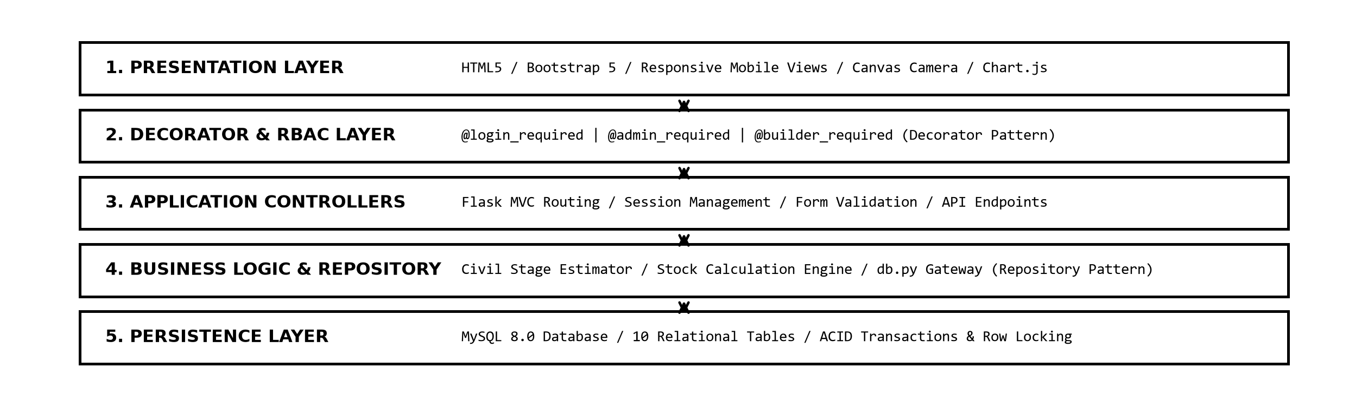
Figure 1: Implementation Architecture & Design Pattern Interaction Flow.

4. Special Coding Techniques
To satisfy field construction constraints and guarantee transactional safety, the codebase implements four advanced technical solutions:
1. Hardware Webcam Integration & HTML5 Canvas Capture: Field engineers can capture real-time photo evidence of completed construction milestones using client-side WebRTC (`navigator.mediaDevices.getUserMedia()`). The video frame is rendered onto an HTML5 `<canvas>`, converted to a compressed Base64 data payload, and submitted with progress updates to verify physical work before admin approval.
2. Dynamic SVG QR Code Generation: Programmatically generates high-contrast QR codes for each house plot in memory using Python's `qrcode` library. Scanning the QR code affixed to a construction pillar immediately directs the mobile engineer to that plot's active progress and material requisition portal.
3. Atomic Row Locking (`SELECT ... FOR UPDATE`): During inventory outward consumption, the system initiates an explicit database transaction with `SELECT ... FOR UPDATE` on the material row. This row-level lock prevents race conditions and phantom reads when concurrent site engineers log material usage simultaneously.
4. Strict Parameterized SQL Sanitization: All dynamic user inputs are passed as separate parameterized tuples to MySQL prepared statements (`%s` markers). This completely neutralizes SQL injection vulnerabilities.
5. Code Quality & Reliability Enforcement
To maintain high code maintainability and eliminate mathematical inaccuracies, the system adheres to three core quality rules:
1. Strict PEP 8 Compliance: Python code is structured with 4-space indentation, descriptive snake_case naming, modular functions, and standard docstrings, verified via flake8 static analysis.
2. Exact Financial & Inventory Arithmetic: All currency calculations and material quantities utilize MySQL `DECIMAL(12,2)` and Python's `decimal.Decimal` module rather than binary floating-point numbers, eliminating fractional rounding discrepancies in stock valuations.
3. Deterministic Resource Management: Every database operation wraps cursor and connection lifecycles within `try...except...finally` blocks. The `finally` clause guarantees that cursors and connections are returned to the pool, preventing memory leaks and orphaned locks.
6. Special Tools & Development Utilities
The project was engineered, tested, and deployed using industry-standard development utilities:
• Visual Studio Code: Primary IDE utilizing Python, Pylance, and Jinja2 extensions for rapid debugging and syntax linting.
• MySQL Workbench 8.0: Used for visual relational schema design, ER diagram generation, foreign key verification, and query optimization.
• Git & GitHub: Version control system enforcing feature branches, pull request peer reviews, and commit audit trails.
• Windows PowerShell & Python CLI: Automated database initialization (`init_db()`), sample data seeding (`seed_data.py`), and test runners.

